# Abstract

**Problem Statement**

Shopping was a hassle just a decade ago. People have to rush out to market and have to get their shopping done with less varieties shown by shopkeeper. They have to travel across different market to get the product that they want. With loss of their time, they do have to pay more than the actual cost. Comparisons between products was too difficult.

*Aims of project*

* To develop a web based application to provide the quicker, easier and cost effective shopping experience to the consumers.
* To remove all the issue that are faced during physical market shopping.
* To provide easy comparison to the products they want.

**Problem solution**

‘The Computer store’ is a web based application that automates the shopping process. It is a virtual store on the internet where customers can browse the catalog and select the products of their interest. It will help customers to save their time and have quicker and easier shopping.

*Scope of the Project*

* To provide easier access to shopping who are usually very busy and are unable to have physical access to stores.
* To overcome all the issue experienced during the physical shopping.
* To provide the better knowledge about the product and make easy to choose what they want.

An online ecommerce with the user friendly interface should be developed that overcomes all the issue faced during physical shopping.

# Introduction

The business-to-consumer aspect of product ecommerce is the most visible business use of the World Wide Web (WWW). This project deals with developing an e-commerce website for online product sale. An e-commerce is virtual store on the internet where customers can browse the catalog and select products of their interest. The main purpose of this project is to develop a general purpose e-commerce store where computers, their software’s, accessories and upgrades can be bought from the comfort of home through internet. With the use of this e-commerce, people can have faster, easier and cost effective access to the best products available. They can give feedback to the product through this site. Ones feedback will make other customers aware about the products and also can gain information about the product they intended to buy from real experienced persons.

In order to facilitate customers, a shopping cart is provided where they can temporary store the products of their choice and also can compare their products of their interest.

* 1. Main Features
* Able to view the catalog and choose the product customer interest.
* Users can signup/register their account with their personal, delivery details.
* They can login to the system and have easy access to multiple features like reviewing, commenting and check out.
* No need to train users. It is user friendly.
* Customers can add products to cart and remove as per their needs.
* Able to search the product they want.
* Customer can view the review about the product they want and also can provide review of their experience.
* Customers can view detail product description of their desired product.
* They can have easy comparison to the products, their cost and features.
* Customers can created their account and are able to login to access all facilities faster.
* Customers can easily change their details like profile, delivery address, phone number etc.
  1. Aims

Some of the aims regarding to project are:

* To develop an e-commerce and address the problem faced during physical shopping.
* To provide detail information about the product that the customer need.
  1. Objectives

Some of the main objective regarding to project are:

* To design a user friendly online shopping platform.
* To develop a general purpose e-commerce where products can be bought from the comfort of home through internet.
* To test the application where that fulfills all the necessities and listed requirements.
* To document the final report of process which provides easiness during project updates.
* To improve the efficiency of the application developed.
* To provide access to up-to date products available in the market.
  1. Development Methods

Development methodology is a framework which that can be used to structure, plan and control the process of developing the system. Agile, Scrum, Lean Development (LD), JAD, RAD, Waterfall are some of them.

I prefer Waterfall development methodology which is the structured development process which describes a development method that is rigid and linear. It allows departmentalization and managerial control. I have choosen this because each phase have been planned in detail which leads the project being delivered on time. (Anon., 2018)

Waterfall methodology has several phases which are given bellow:

* Planning
* Analysis
* Design
* Development/Implementation
* Maintenance/Testing

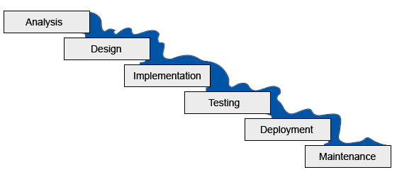

Fig : Waterfall methodology

All the phase from Analysis to Maintenance are done in order. It is difficult to go back and change something that was not thought of in the concept stage.

# Analysis Specification